PROJECT PLANNING PHASE
Project Planning Template (Product Backlog, Sprint Planning, Stories, Story Points)
Date | 02 October 2026
Project Name | Automated Network Request Management in ServiceNow
Maximum Marks | 5 Marks

Product Backlog, Sprint Schedule, and Estimation
Sprint | Functional Requirement (Epic) | User Story Number | User Story / Task | Story Points | Priority
Sprint-1 | Catalog & Form Setup | USN-1 | Create Network Request Catalog Item | 3 | High
Sprint-1 | Catalog & Form Setup | USN-2 | Configure requester and network request catalog variables | 3 | High
Sprint-1 | Catalog & Form Setup | USN-3 | Configure Requester Information variable set and Catalog UI Policy | 3 | High
Sprint-2 | Workflow, Approval & Data | USN-4 | Configure Flow Designer to retrieve Network Request catalog variables | 5 | High
Sprint-2 | Workflow, Approval & Data | USN-5 | Create and map Database Tables (u_database_tables) operational record | 5 | High
Sprint-2 | Workflow, Approval & Data | USN-6 | Configure approval action and approval-status branching | 3 | High
Sprint-2 | Workflow, Approval & Data | USN-7 | Maintain REQ/RITM lifecycle and request status context | 2 | Medium
Sprint-3 | Notifications, Security & Fulfilment | USN-8 | Configure request-created and request-resolved notifications | 3 | High
Sprint-3 | Notifications, Security & Fulfilment | USN-9 | Configure Create, Read, Write and Delete ACL access | 3 | High
Sprint-3 | Notifications, Security & Fulfilment | USN-10 | Configure Approval Request relationship and operational-record visibility | 3 | High
Sprint-3 | Notifications, Security & Fulfilment | USN-11 | Validate fulfilment handoff and request lifecycle stages | 4 | High
Sprint-4 | Testing, Debugging & Deployment | USN-12 | Test catalog variable retrieval and variable-to-field mappings | 3 | High
Sprint-4 | Testing, Debugging & Deployment | USN-13 | Use Flow Execution Details to debug workflow and condition failures | 2 | Medium
Sprint-4 | Testing, Debugging & Deployment | USN-14 | Perform end-to-end approval, notification and status testing | 3 | High
Sprint-4 | Testing, Debugging & Deployment | USN-15 | Perform UAT and role/security testing | 3 | High
Sprint-4 | Testing, Debugging & Deployment | USN-16 | Prepare deployment / recreation documentation for a new PDI | 5 | High

Project Tracker, Velocity & Burndown Chart
Sprint | Total Story Points | Duration | Sprint Start | Sprint End (Planned) | Story Points Completed | Release Status
Sprint-1 | 9 | 5 Days | Day 1 | Day 5 | 9 | Completed
Sprint-2 | 15 | 5 Days | Day 6 | Day 10 | 15 | Completed
Sprint-3 | 13 | 5 Days | Day 11 | Day 15 | 13 | Completed
Sprint-4 | 16 | 5 Days | Day 16 | Day 20 | 16 | Completed
Velocity
Total completed story points = 53. Number of sprints = 4. Average team velocity = 53 / 4 = 13.25 story points per sprint.
Burndown Chart
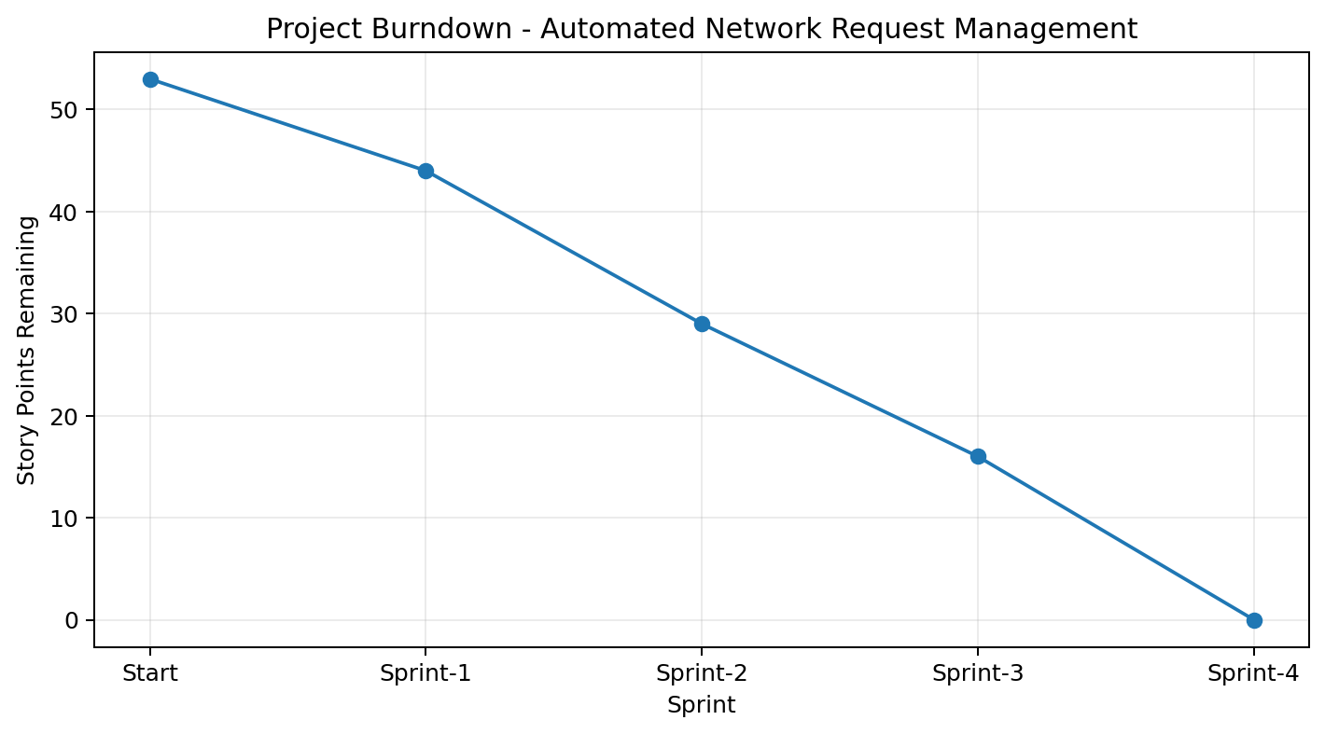
Figure 1. Remaining story points after each completed sprint.
The burndown chart uses the same relative 20-day schedule as the uploaded planning template: four 5-day sprints. It represents remaining story points after each sprint and does not claim exact historical calendar dates.
Sprint Release Summary
Sprint | Release Outcome
Sprint-1 | Network Request catalog item, requester/network variables, Requester Information variable set, and dynamic form behaviour completed.
Sprint-2 | Flow Designer automation, catalog-variable retrieval, Database Tables mapping, approval processing, and REQ/RITM request context completed.
Sprint-3 | Request notifications, ACL security, Approval Request relationship, operational visibility, and fulfilment/lifecycle handoff completed.
Sprint-4 | Variable/mapping tests, Flow Execution debugging, end-to-end workflow testing, UAT/security testing, and deployment/recreation documentation completed.

Planning Note: Exact historical sprint dates and individual team-member assignments were not supplied in the source material. The tracker therefore uses a relative 20-day schedule (four 5-day sprints), while preserving the sprint sequence, backlog structure, story-point estimation, and completed-work format of the reference.

